1) Rate of change:
a)
t (years) | 1 | 2 | 3 | 4
f(t) | 4 | 8 | 10 | 16

Find the rate of change from 2 years to 4 years.

2) The graph below gives the price of a stock over time (in years). Find the average rate of change from Year 2 to Year
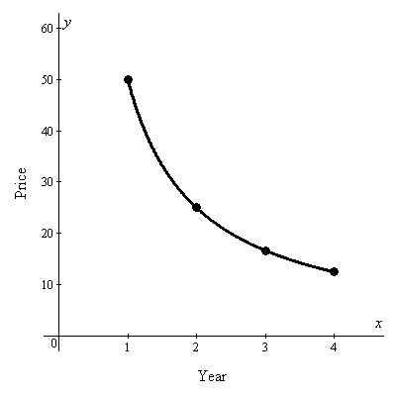
(1, 50)
(2, 26)
(3, 17)
(4, 12)
3) Compare the rate of change of f(x) = 3x + 4 and g(x) = 3^{x} + 4 over the interval [0, 4].

4) Characteristics of functions:
Graph | Domain and  Range | X & Y intercepts | Max or Min | Increasing or Decreasing
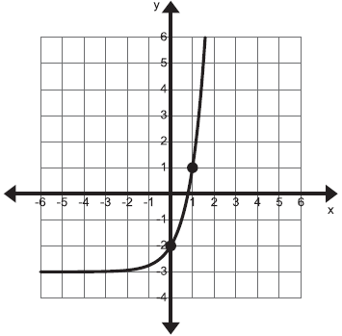
5)  Characteristics of functions:  Graph | Domain and  Range | X & Y intercepts | Max or Min | Increasing or Decreasing
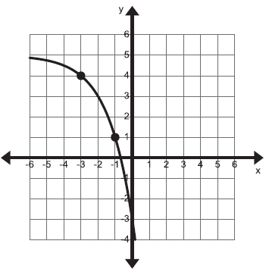

- Sequences:
Write the explicit formula for the following sequences. Then, find a₁₀.
3, 7, 11, 15, 19, ...

4, 12, 36, 108, 324, ...

- Sequences:
Write the explicit formula for the following sequences. Then, find a₁₀.

56, 28, 14, 7, 3.5, …

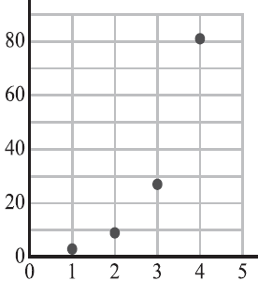
8) After knee surgery, your trainer tells you to return to your jogging program slowly. He suggests jogging for 12 minutes each day for the first week. Each week thereafter, he suggests that you increase that time by 6 minutes per day. How many weeks will it be before you are up to jogging 60 minutes per day?

9Transformations:

a) Describe the transformations that would be made to f(x) = 2^{x} to draw the following functions.

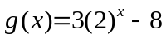

b) Give the domain, range, and asymptotes for the function in part a.

10) Give the equation of the 2nd function that is not labeled.
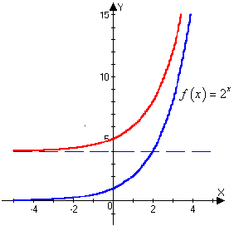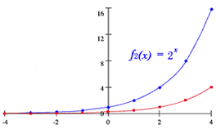

- Operations with Functions:
Given the following functions, perform the indicated operation.

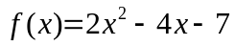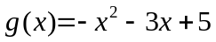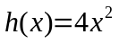

- g(-3)

- f(3) – g(3)

- f(x) – g(x)

- 2g(x) + 3f(x)

- g(x) – 2f(x)

- 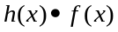

- Exponential Word Problems:

The student population in a high school increases by 6% a year. When it opened, the school had 1340 students.
a) Write a formula that models this situation.

b) How many students will there be in 5 years?

- If the maximum number of students the school can hold is 2400, how many years will it take to reach that number?

13) A new car has a value of $28,000 and depreciates by 15 % a year.
a) Write a formula that models this situation.

b) What will be the value in 3 years?

c) How many years will it take to have a value less than $10,000?

