### Name: __________________________________________ Date: _____________________________

**Practice**

1. Translate the image by (x + 4, y – 6)



1. Translate the image by (3x – 1, y + 5)



1. Find the pre-image (x – 9, y + 13)



1. Find the pre-image (x + 7, y – 19)



1. Translate the image.

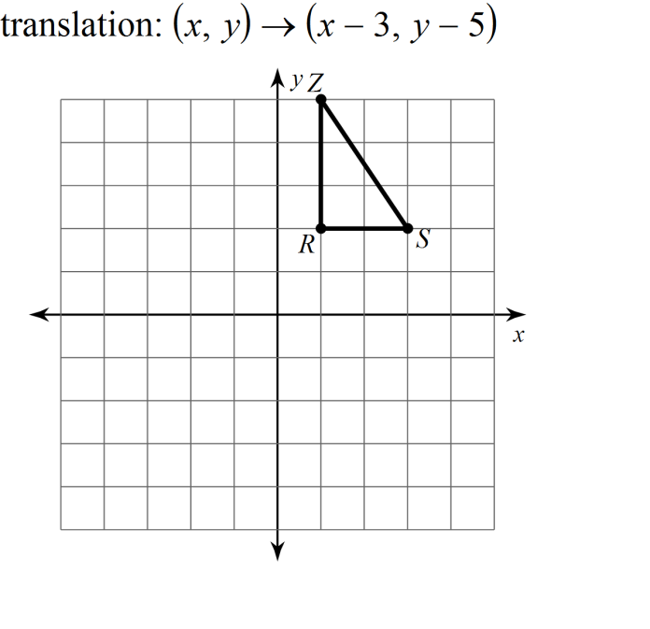

1. Translate the image.

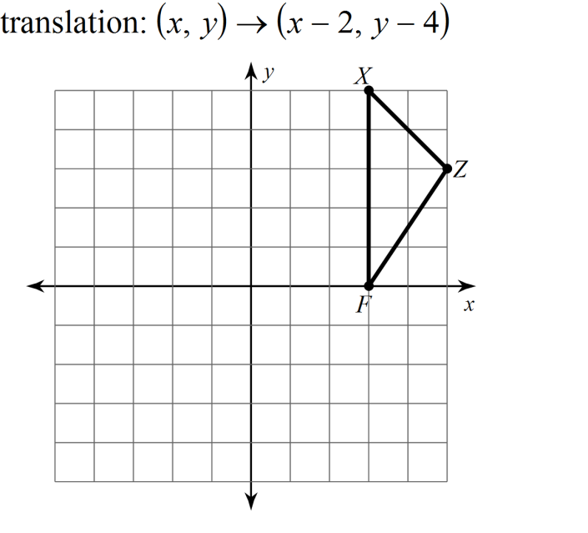

1. Translate the image.

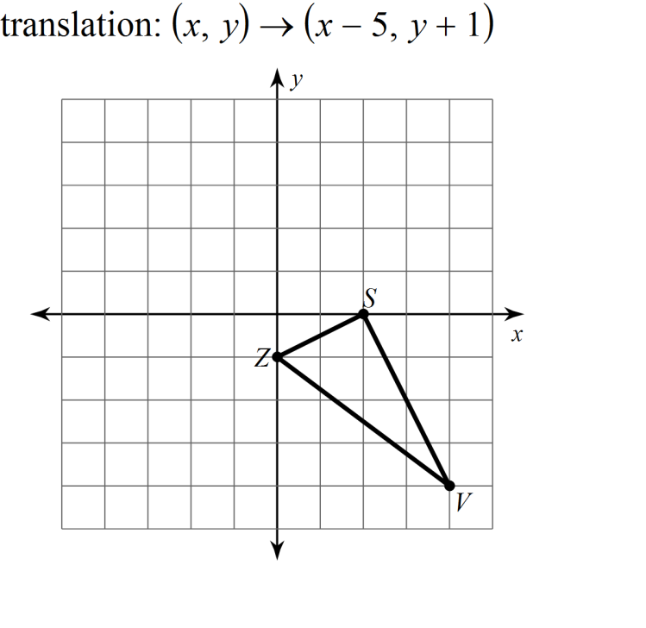

1. Translate the image.

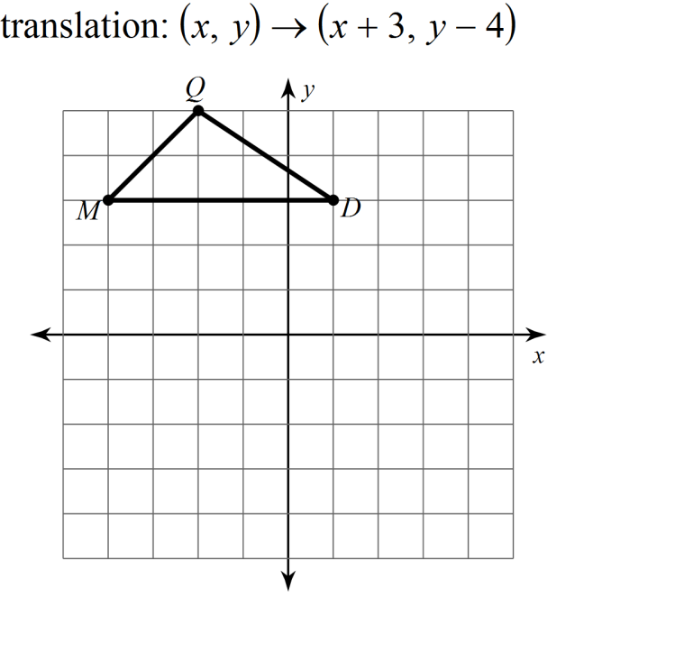

Write a rule for the given translation.

