### Name: __________________________________________ Date: _____________________________

Find the coordinates of the vertices of each figure after the given transformation.

1. Reflection across the x-axis.



1. Reflect across the y-axis.



1. Reflect across the line y = x.



1. Reflect across the line y = -x.



1. Reflect across the y-axis.



1. Reflect across the line y = -x.



1. Reflect across the x-axis.



1. Reflect across the line y = x.



1. Reflect the image across the y-axis.

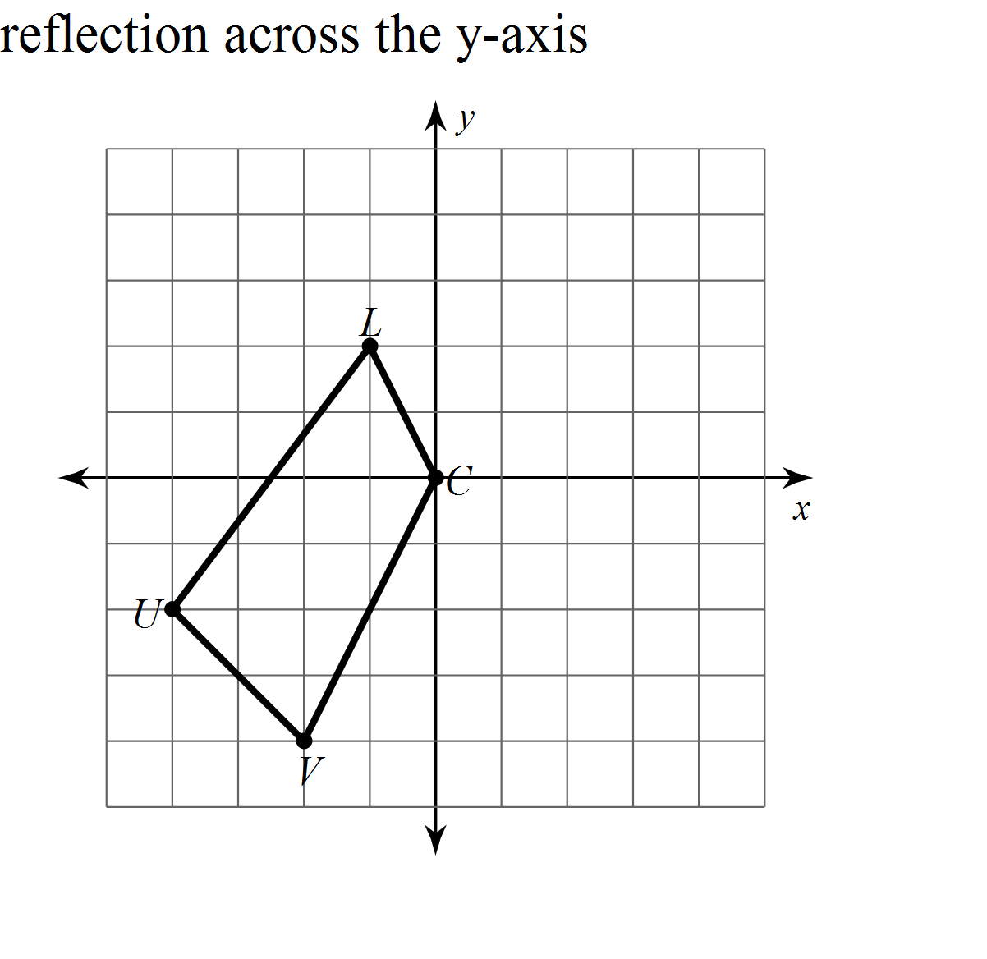

1. Reflect the image across the x-axis.

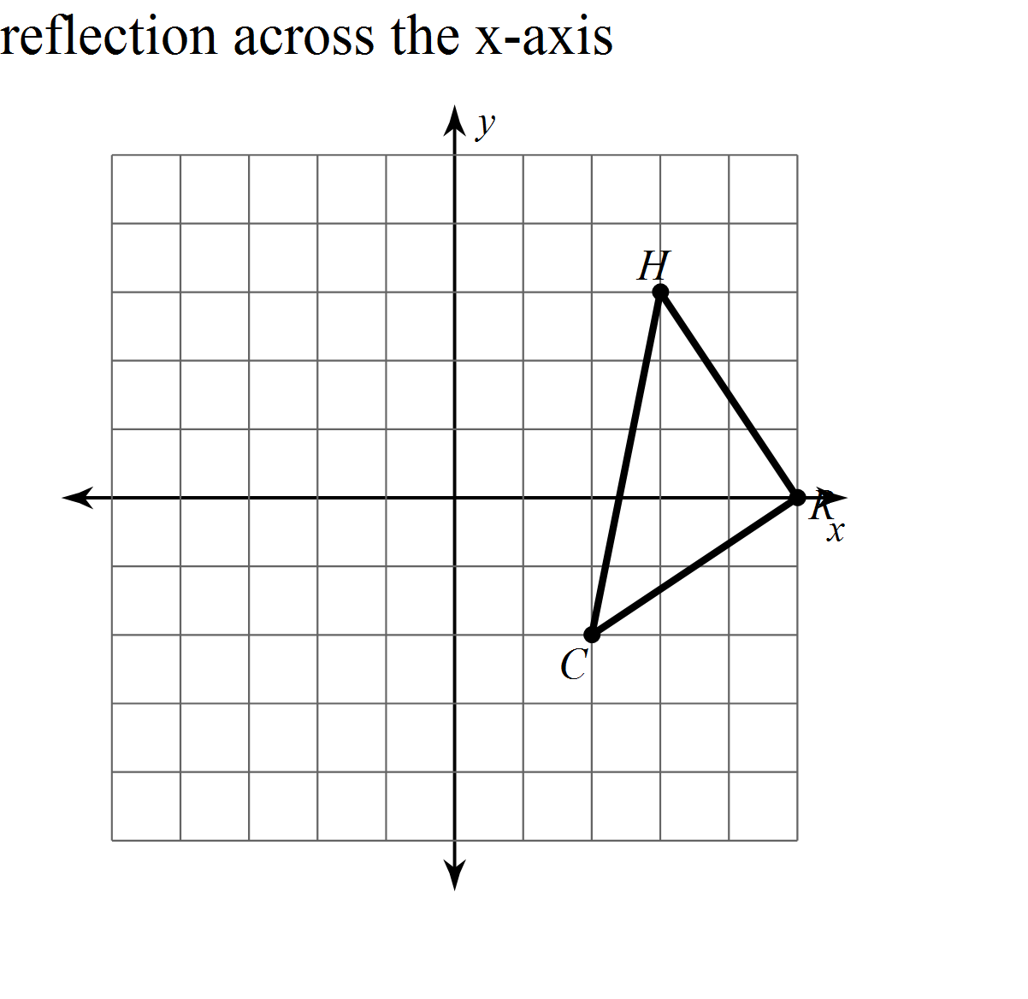

1. Reflect the image across the y-axis.

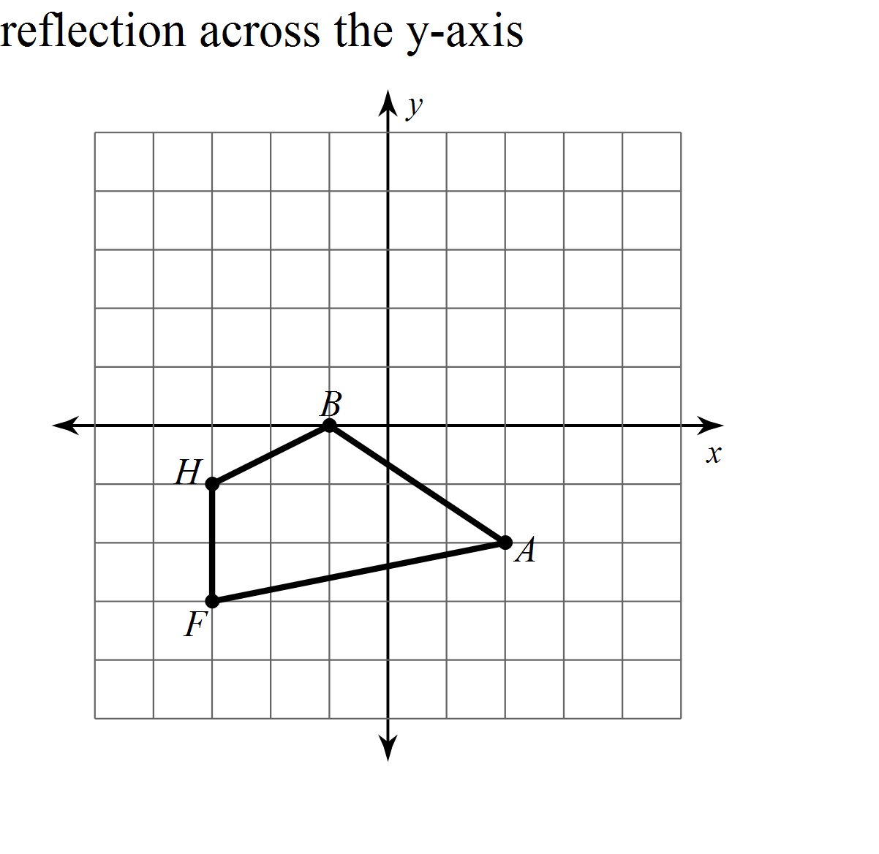

1. Reflect the image across the x-axis.

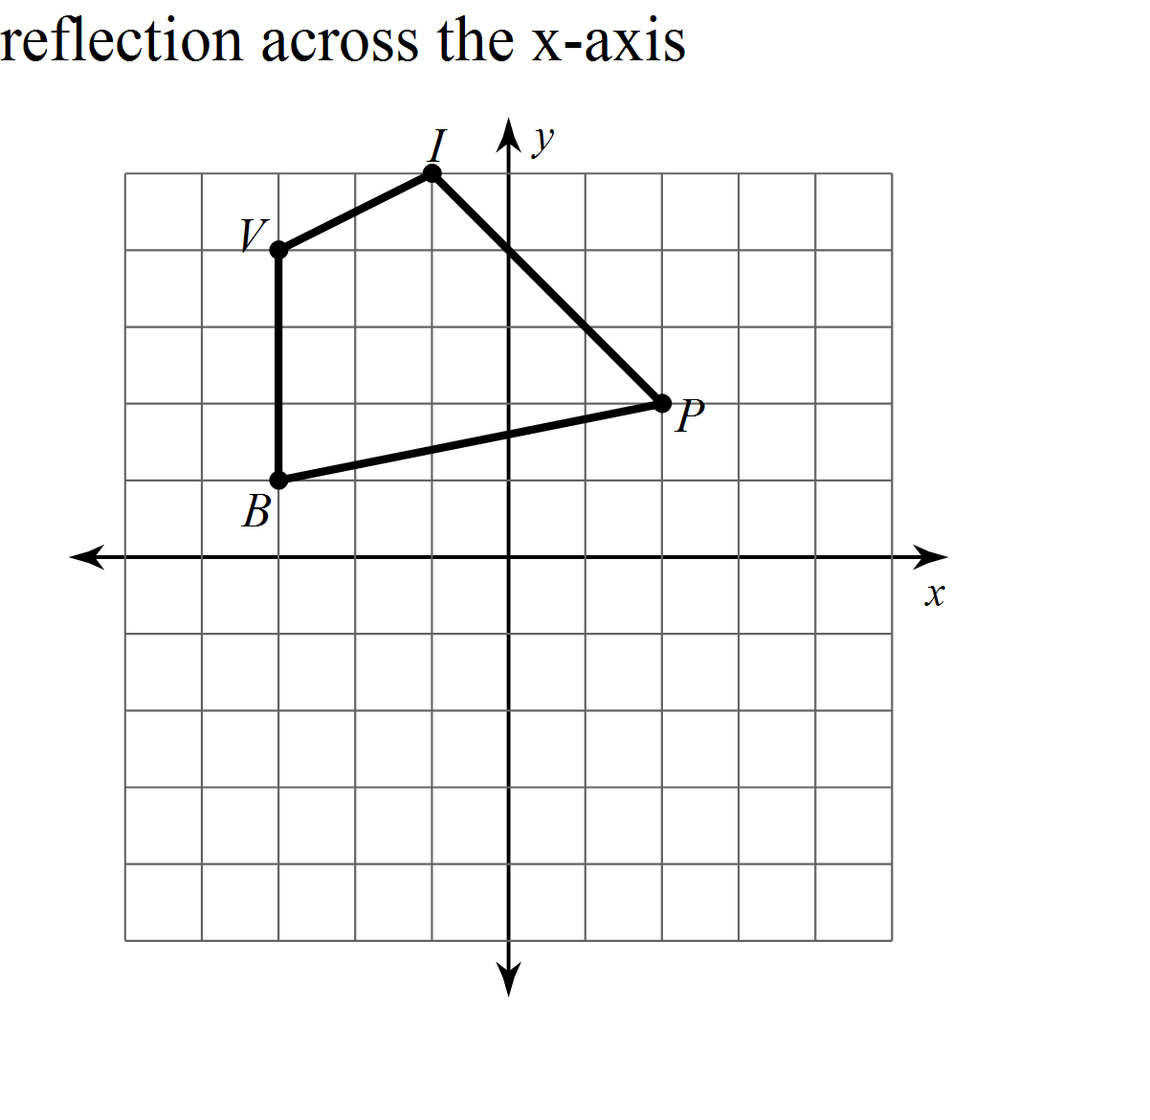

Write a rule to describe each transformation.

1. 
2. 
3. 
4. 