Name: __________________________________________ Date: _____________________________
COMBOS

Graph the image of A(1, -3) & each transformation.

- Translation: (x + 2, y )
Reflection: across the x-axis
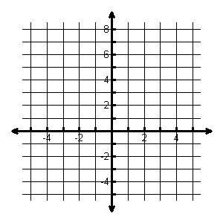

- Reflection: across y = 2 Translation: (x – 4, y – 3)

- Translation: (x – 3, y + 2)
Reflection: across x = 1

The endpoints of CD are C(1, 2) and D(5, 4). Graph the image of CD & each transformation.

- Reflection: across the x-axis
Translation: (x – 4, y)

- Translation: (x , y + 2)
Reflection: across y = x

Write the rule for the combinations that were applied to ΔABC. **Pay attention to the order**

The vertices of ∆ABC are A(2,4), B(7,6), and C(5,3). Graph the image of ∆ABC & each transformation.
- Translation: (x – 4, y – 3)
Reflection: across the x-axis
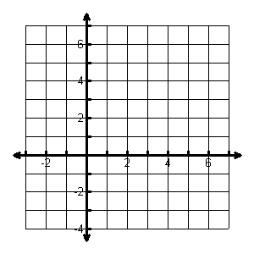
- Reflection: across the y-axis
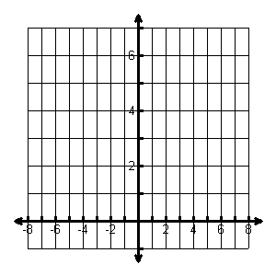
Translation: (x + 2, y)

The vertices of ∆DEF are D(2,4), E(7,6), and F(5,3). Graph the image of ∆DEF & each transformation.
- Translation: (x + 3, y – 5)
Reflection: across the y-axis
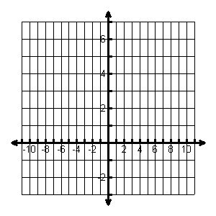

- Reflection: across the y - axis
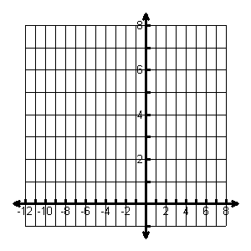
Translation: (x – 4, y + 1)

In the diagram, AB is the pre-image of a combination.
- Which segment is a translation of AB?

- Which segment is a reflection of A’B’?

- Name the line of reflection.

- Write a rule to describe the translation.

